Tender Bidding and Financial Performance Dashboards
1.OVERVIEW
This project focuses on analyzing tender- related financial data to evaluate project costs, bid amounts, and profitability.
It helps management identify high-value tenders, compare bidder performance and track financial outcomes through interactive dashboards.
OBJECTIVE
- To analyze and visualize tender -wise financial data.
- To identify cost-effective and profitable tenders.
- To monitor department – wise tender performance.
- To support better bidding and budget planning decisions.
2. Data source
- Source Description and Timeline: Data government .in
Google dataset search and 2021-2022.
- Domain: Finance Tender
3. Problem Statement
To design and develop an interactive dashboard using Power BI / Excel that visualizes tender data and helps decision-makers monitor:
- Total tenders and values
- Profit/loss trends
- Department-wise tender performance
- Year-wise and status-wise insights

To design and develop an interactive dashboard using Power BI / Excel that visualizes tender data and helps decision-makers monitor:
- Total tenders and values
- Profit/loss trends
- Department-wise tender performance
- Year-wise and status-wise insights
4.Attribute
 | Attribute Name | Description
1 | Tender ID | Unique identification number for each tender
2 | Department Name | The department or sector issuing the tender (e.g., PWD, Finance Dept.)
3 | Tender Name / Description | Short description of the tender project
4 | Tender Amount | The total estimated tender value announced
5 | Bid Amount | The amount quoted by the bidder
6 | Final Approved Cost | The amount approved for the winning bidder
7 | Profit / Loss | Calculated as Bid Amount – Final Cost
8 | Tender Date | The date when the tender was issued
9 | Submission Date | Deadline for submitting the bid
10 | Status | Whether the tender was Won or Lost

5. Tools & Technologies
- Excel – To store, clean, and organize tender data.
- Power BI – To create interactive financial dashboards.
- Power Query – For data cleaning and transformation.
- DAX – To calculate profit, total amount, and KPIs.
- Charts & Visuals – To display tender trends, profit/loss, and department.
6.Data pre -Processing
- Removed duplicate tender records.
- Checked and filled missing values Department or Amount.
- Loaded dataset from Excel into Power BI using Power Query.
- Used “Remove Duplicates” and “Replace Errors”.
- Applied data type changes (Date → Date type, Amount → Decimal).

7.Data modelling and DAX
In Power BI, data modelling means connecting different tables and defining relationships between them.
It helps create interactive dashboards where visuals can work together.

Name | Description
Tender | Main table with tender details (Tender ID, Amount, Profit, etc.)
Department Table | Department names and codes
Date Table | Calendar table (for Year, Month, Quarter filters)

Total Tender Value = SUM (Tender Data [Tender Amount])

Average Profit = AVERAGE (Tender Data [Profit])
8.Analysis and Visualizations
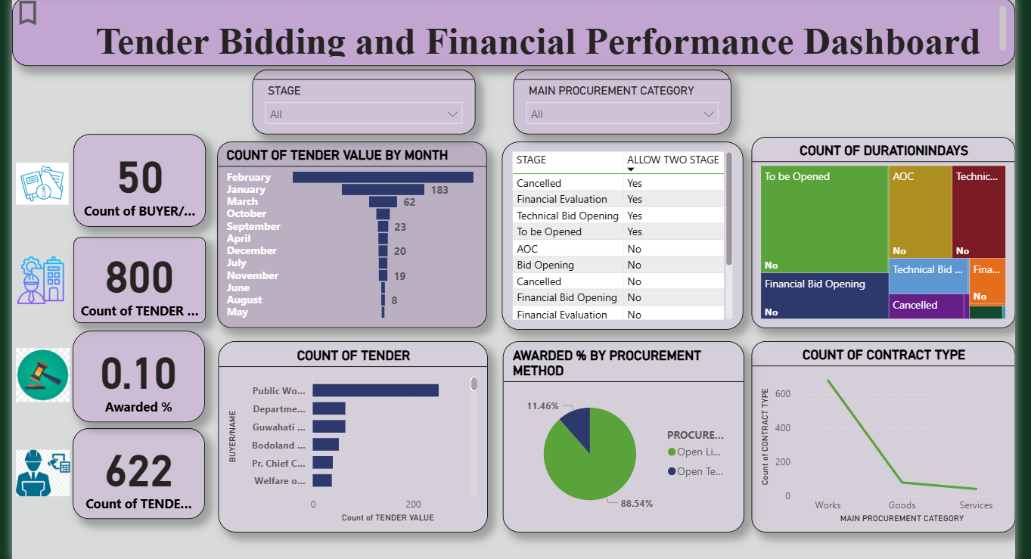

- KPI Cards – Show key values like Total Tender Value, Profit, and Loss.
- Bar Chart – Compare Department-wise Tender Amount and Profit.
- Pie Chart – Display Tender Status
- Table Visual – Show detailed Tender-wise Financial Data.
9.Insights & Conclusion
- Around of tenders resulted in profit.
- Public Works Department handled the highest tender value.
- South Region showed the best overall financial performance.
Key points
- South Region performed best in terms of tender success rate.
- Average profit margin improved compared to the previous year.
- High-value tenders showed more financial risk and lower success percentage.
- Public Works Department contributed the highest tender value and profit.
10. Conclusion

The Finance Tender Project shows how Excel and Power BI work together effectively for end analysis.
Excel helped in data cleaning and preparation, while Power BI enabled powerful visualizations and insights.
Together, they provided a clear, accurate, and data-driven understanding of tender performance and profitability.

